Hack3d 2023 Final Challenge Problem Statement
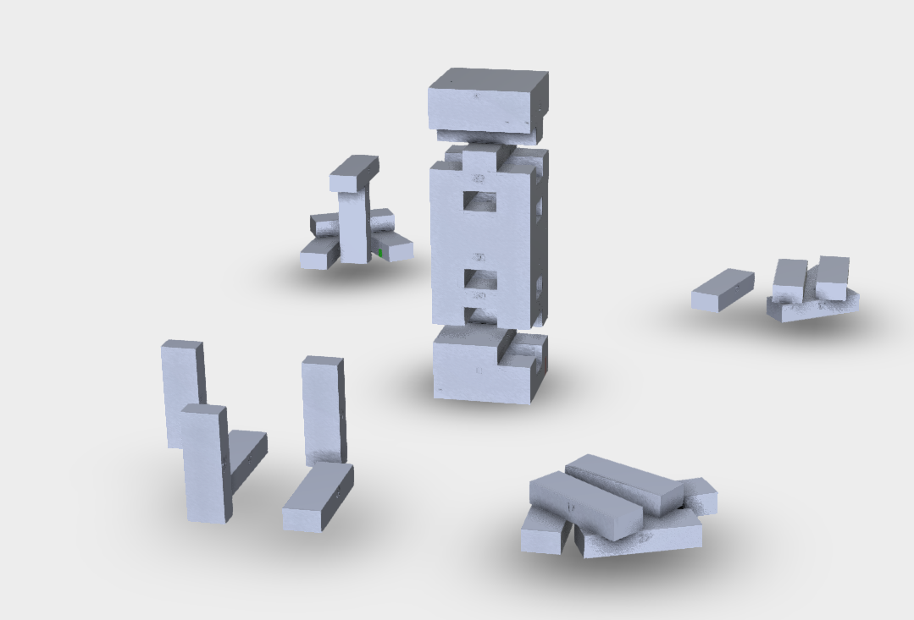

NYU Subsidiary Nyasbro (Red Team) is releasing a new board game. In our previous releases we’ve left clues to our new release in our previous release 𝜈-Jenga.
Your goal (as the blue team) is to examine the 𝜈-Jenga files and determine what the new game we will be releasing is.

Submissions:
- Each team will submit a zip file (HACK3D_Team Name.zip) via EMAIL by 5pm EST containing:
  - A detailed word document which includes:
    - A description of the brainstorming process in the team’s approach and explanation of all procedures used in finding clues.
    - A summary of any other approach attempted that may not have been successful to provide insight into your effort level and thought process.
  - Any supplementary file to support your report (CAD/STL files, programming scripts, images)
- Each team will be required to submit a powerpoint presentation via EMAIL by 8am EST Nov. 9 detailing their process in solving the puzzles.
- Each team will be required to present their findings to our judge panel on November 9th from 10AM - 11AM. (10 minute presentation including Q&A )

